Here are a couple of sample e-mail message templates for use when introducing miSecureMessages to your clients/prospects. This is suggested content, so feel free to edit:
Sample e-mail message template introducing MSM to clients/prospects:

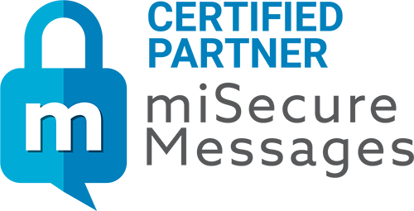

Hello (your client’s name here),
I would like to tell you about a service that we're offering that sends secure messages to your smartphones and mobile devices.
miSecureMessages is a powerful and secure, encrypted messaging application designed as a pager replacement for healthcare organizations, call center, and enterprise environments.
Some of the benefits miSecureMessages has to offer include:

- Secure and encrypted messaging. miSecureMessages is both HIPAA and HITECH complaint.
- Simple and easy to use app. Users will find the miSecureMessages app user friendly and easy to navigate.
- Streamlined communications. miSecureMessages is an integral part of a complete secure messaging system. Streamline your communications with various integrations to meet the needs of your team.
- Save Critical Time. Staff can communicate quickly and efficiently. Features such as Persistent Alerts and High Priority settings help ensure your messages are acknowledged in a timely manner.

miSecureMessages can easily generate customized reports for you so you can track and keep a record of all your messages. I can help you build your business and generate profits by presenting data to use in developing new business.
May I set up an in-depth demo for you?
Sincerely,
(your name and contact information here)

Sample longer e-mail message template introducing MSM to clients/prospects:
Hello (your client’s name here),
I would like to tell you about a service that we're offering that sends secure messages to your smartphones and mobile devices. It has begun to replace and supplement paging technology, and enables two-way instant and secure communications.
miSecureMessages is a powerful and secure, encrypted messaging application designed as a pager replacement for healthcare organizations, call center, and enterprise environments. Built for iPhone®, iPad™ Apple Watch™ and Android™ mobile devices, miSecureMessages replaces outdated paging technology and enables users to send and receive secure encrypted messages from anywhere they have mobile data or Wi-Fi coverage.
With an easy-to-use app interface, a US-based customer support team, and military grade encryption, miSecureMessages is simple, streamlined, and secure. Some of the benefits miSecureMessages has to offer include:

- Secure and encrypted messaging. Messages are not stored on devices, passcodes or fingerprint scans can be required, and access can be remotely disabled, making miSecureMessages HIPAA and HITECH complaint.
- Simple and easy to use app. You’ll find the miSecureMessages app user friendly and easy to navigate. Quickly respond to messages using text, voice or customized quick phrases. Easily attach photos, videos, or voice recordings.
- Streamlined communications. miSecureMessages is an integral part of a complete secure messaging system. Streamline your communications with various integrations to meet the needs of your team.
- Save Critical Time. miSecureMessages makes secure texting fast and easy! Staff can communicate quickly and efficiently. Features such as Persistent Alerts and High Priority settings help ensure your messages are acknowledged in a timely manner.

Using miSecureMessages, we can easily generate customized reports for you so you can track and keep a record of all your messages. That means I can help you build your business and generate profits by presenting data to use in developing new business.
May I set up an in-depth demo for you?
Sincerely,
(your name and contact information here)

